## Big Mountain Resort Analysis and Recomendations

Big Mountain Ski Resort(BMSR) in Montana is seeking to optimize their ticket prices to offset the cost of new $1.54 million dollar skilift and have guidance for future facility investment plans before the next skiing season. In order to determine the optimal pricing strategy for BMSR a dataset containing information about the terrain, facilities, and operation of 330 similar resorts in 35 states across the United States was analyzed.

To get the data into a useable format a number of methods for collecting and organizing the data were applied. Entries with missing data were removed after their useful data were captured. This amounted to 14% of the dataset leaving us with 277 entries with price information. Features are examined in a number of ways to tease out useful infromation from the dataset such as what are typical prices for weekday vs weekend, and wether state should be considered in the pricing region. Figure 1 seen here shows the average price for weekday and weekend and how it varies by state. From this it can be seen that aside from a few luxury outliers most weekend prices fall in the $25-100 range, and that Montana’s fell between $40-80 and was the same for weekdays and weekends. 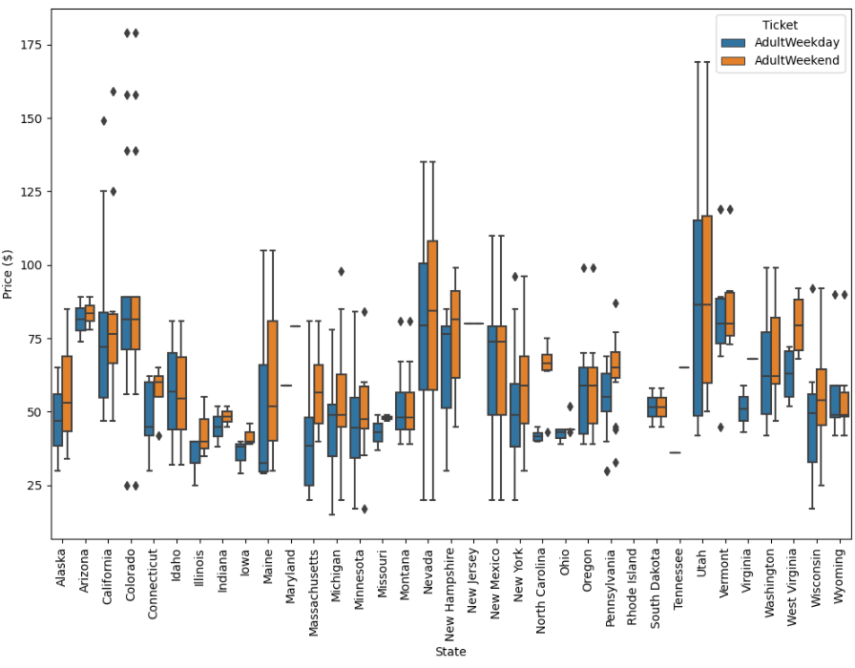

An initial round of analysis of the dataset determined that state did not significantly impact the pricing of ski passes but other features such as highest vertical drop, summit elevation, the number of runs, longest run, and area covered by snow making equipment all have strong correlations with higher ticket prices as seen in figure 2. These features are among those which we will use to determine which changes can have the strongest impact on pricing changes.

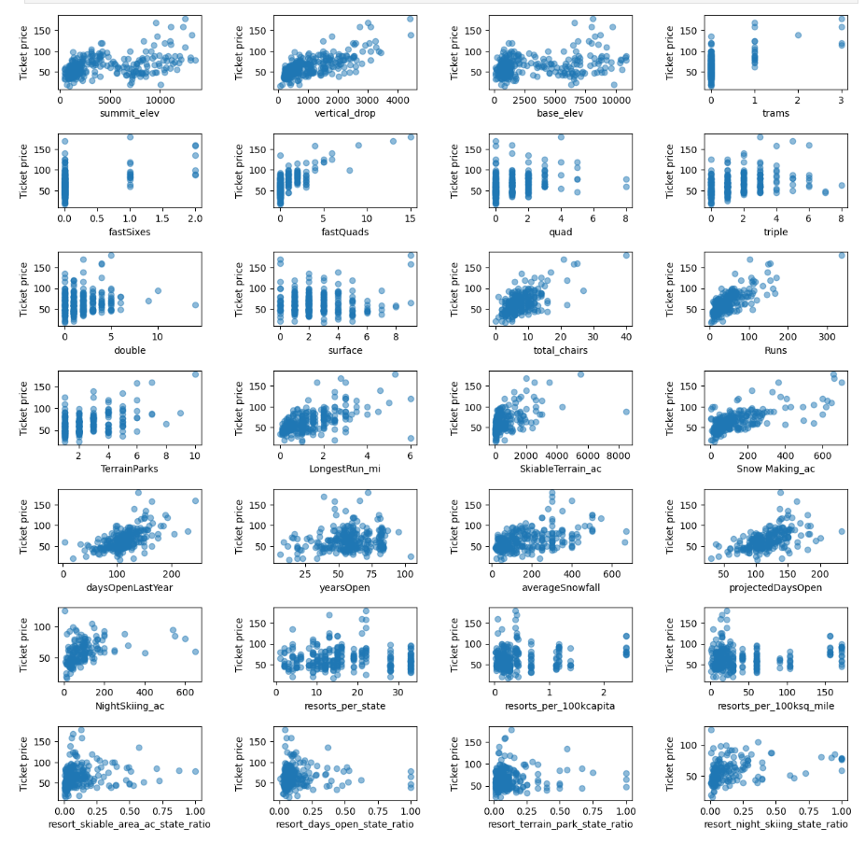

Using several different modeling techniques and comparing them, establishing a baseline using the mean, using linear regression, and using a random forest model, the latter performed the best and was used to come to our recommendations.

It is our recommendation that big mountain close their least used run and replace it with a new one with a new lift with 150ft increase in vertical drop. This scenario increases support for ticket price by $1.99 and over the season, this could be expected to amount to $3474638 of additional revenue which would pay for itself and cover the cost of the new lift. Regardless, it seems as though Big Mountain is positioned in the market to raise prices due to its strong features relative to similarly priced competitors.

